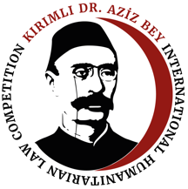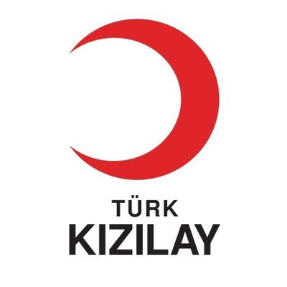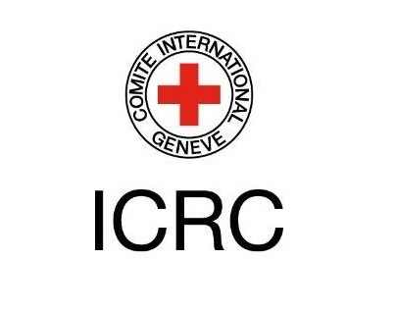
KIRIMLI DR. AZİZ BEY INTERNATIONAL HUMANITARIAN LAW COMPETITION & ADVANCED SUMMER SCHOOL
Application Form for the 2nd Edition
30 July-8 August 2021
Heybeliada (Island) – Istanbul
General Information
Academic affiliation of the team members:
Website of the academic institution:
Contact member of the team:
Team Members
- Member 1
Name and Surname:
Date of Birth:
Study Program & Grade:
Contact information (Email & Mobile):
- Member 2
Name and Surname:
Date of Birth:
Study Program & Grade:
Contact information (Email & Mobile):
- Member 3
Name and Surname:
Date of Birth:
Study Program & Grade:
Contact information (Email & Mobile):
Evaluation Questions
Please answer the following questions by respecting word limits. The aggregated points will make the 60% of the final assessment.
- You are working for the leading newspaper of Utopia. Your editor asked you to write a piece on the ICRC’s 2019 Challenges Report. You need to highlight the most important challenge in your opinion and explain why such a challenge is more pressing than others. (400 words, including footnotes) (30%)

- What is the origin of the legal discussion “overall control v effective control test” in internationalization of the armed conflict? Which test is more suitable in today’s reality? Explain your preference in-detail and refute the alternative. (1000 words including footnotes) (50%)

- Why is your team best placed to be selected for the Kırımlı Dr. Aziz Bey IHL Moot Court Competition & Advanced Summer School? (300 words) (20%)

IMPORTANT: Please submit this file with your CVs and an official document proving you are enrolled as a student to an undergraduate or a master program as one PDF file to azizbeyihl@icil.org.tr before the application deadline.
www.azizbeyihl.com

